Lexical Database

What is Lexical Database
# Source: Chatgpt (GPT-4-turbo) at [7/29/2025]
A Lexical Database is a digitally stored and structured collection of lexical entries that contains detailed information about words and their properties. It is similar to a computational lexicon, but more general: it may be used by humans, machines, or both, and may serve educational, linguistic, or computational purposes.

🔹 Key Features of a Lexical Database
# Source: Chatgpt (GPT-4-turbo) at [7/29/2025]
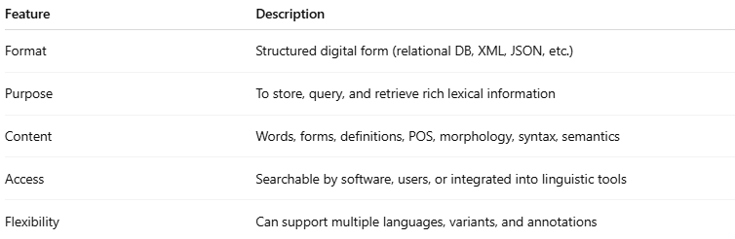
Feature | Description
Format | Structured digital form (relational DB, XML, JSON, etc.)
Purpose | To store, query, and retrieve rich lexical information
Content | Words, forms, definitions, POS, morphology, syntax, semantics
Access | Searchable by software, users, or integrated into linguistic tools
Flexibility | Can support multiple languages, variants, and annotations

🔹 What Does a Lexical Database Include?
# Source: Chatgpt (GPT-4-turbo) at [7/29/2025]
A lexical database typically includes:
- Lemma (base form)
- Inflected forms and derivational variants
- Part of speech (noun, verb, etc.)
- Pronunciation
- Definitions and examples
- Synonyms/antonyms
- Morphological rules
- Syntactic behavior
- Semantic relationships (hypernyms, hyponyms, meronyms)
- Cross-linguistic mappings (in multilingual databases)

🔹 Examples of Lexical Databases
# Source: Chatgpt (GPT-4-turbo) at [7/29/2025]
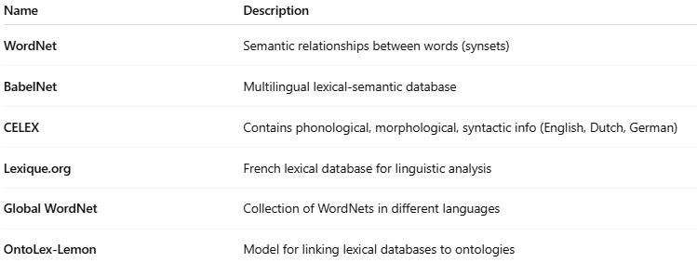
Name | Description
WordNet | Semantic relationships between words (synsets)
BabelNet | Multilingual lexical-semantic database
CELEX | Contains phonological, morphological, syntactic info (English, Dutch, German)
Lexique.org | French lexical database for linguistic analysis
Global WordNet | Collection of WordNets in different languages
OntoLex-Lemon | Model for linking lexical databases to ontologies

🔹 Lexical Database vs Other Lexicons
# Source: Chatgpt (GPT-4-turbo) at [7/29/2025]
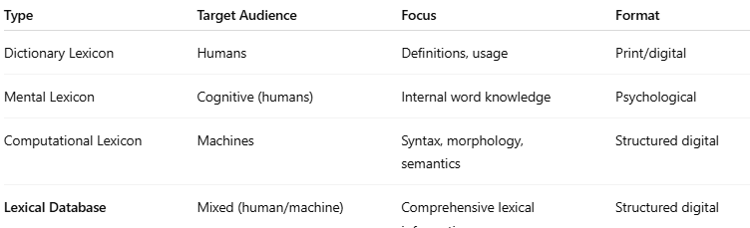
Type | Target Audience | Focus | Format
Dictionary Lexicon | Humans | Definitions, usage | Print/digital
Mental Lexicon | Cognitive (humans) | Internal word knowledge | Psychological
Computational Lexicon | Machines | Syntax, morphology, semantics | Structured digital
Lexical Database | Mixed (human/machine) | Comprehensive lexical information | Structured digital

🔹 Typical Use Cases
# Source: Chatgpt (GPT-4-turbo) at [7/29/2025]
- Linguistic research
- NLP applications
- Educational tools
- Spell checkers, grammar correctors
- Lexical analysis and generation tools

